STUDENT HANDOUT JAVASCRIPT CHAPTER2
LOOPING INTO JAVASCRIPT
About Workshop
In this workshop, we will cover everything from JavaScript basics to understanding loops, arrays, and the Document Object Model (DOM), which are essential building blocks for creating dynamic and interactive web applications. This chapter is divided into three workshops, each of which demonstrates how JavaScript code can be used to dynamically update and manage elements on your webpage, including job listings, filters, and their associated details. These workshops will also teach you how to utilize DOM manipulation and event handling to achieve these functionalities.The Scrum Master can divide the workshop among team members, and you can proceed to walk through the tasks assigned to you.
WORKSHOP1:
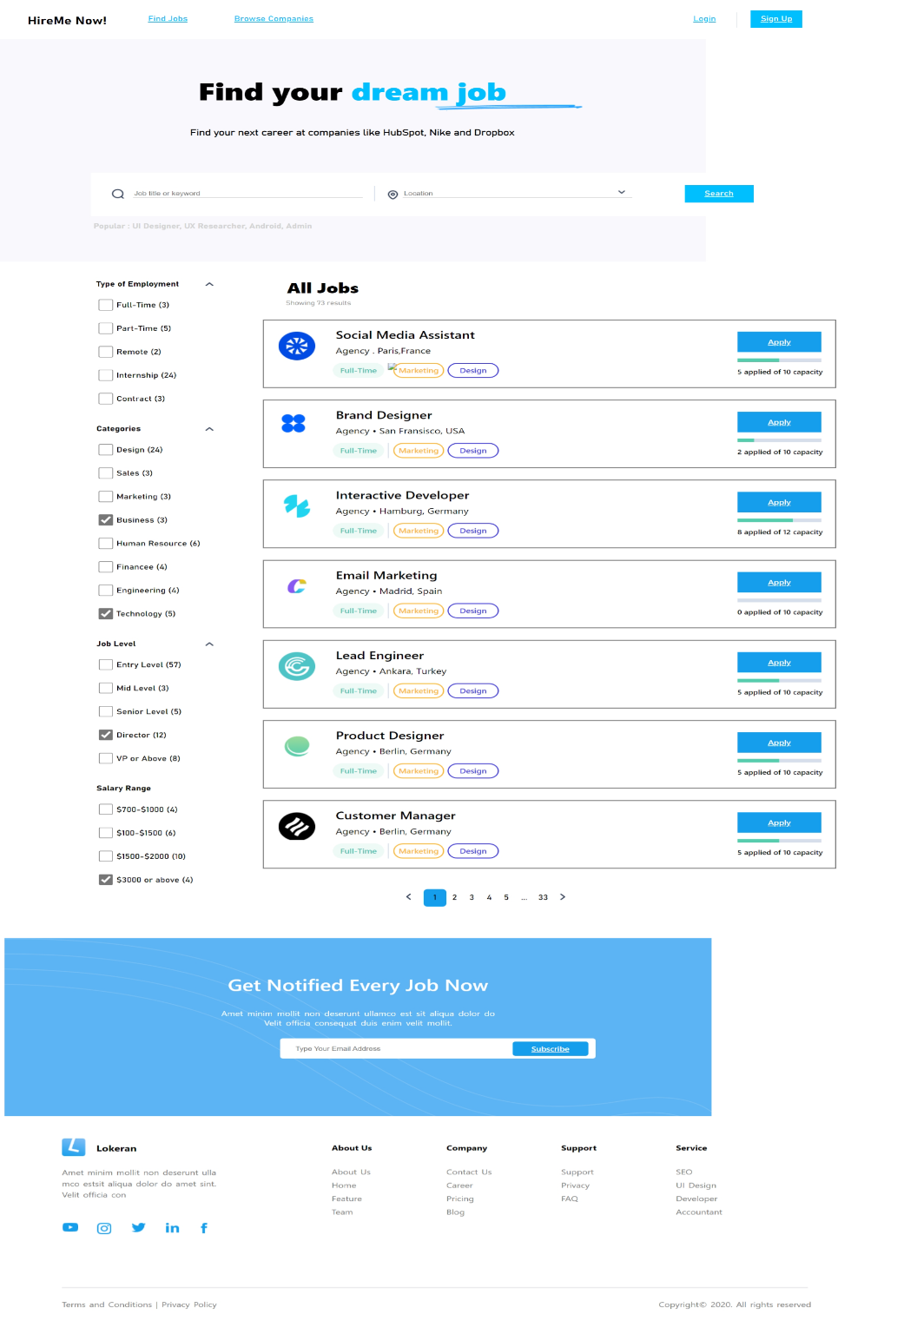
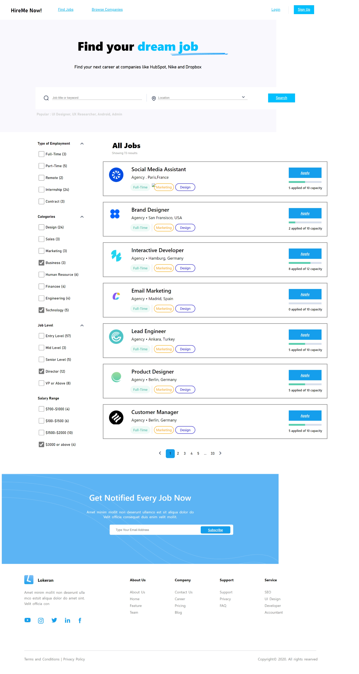

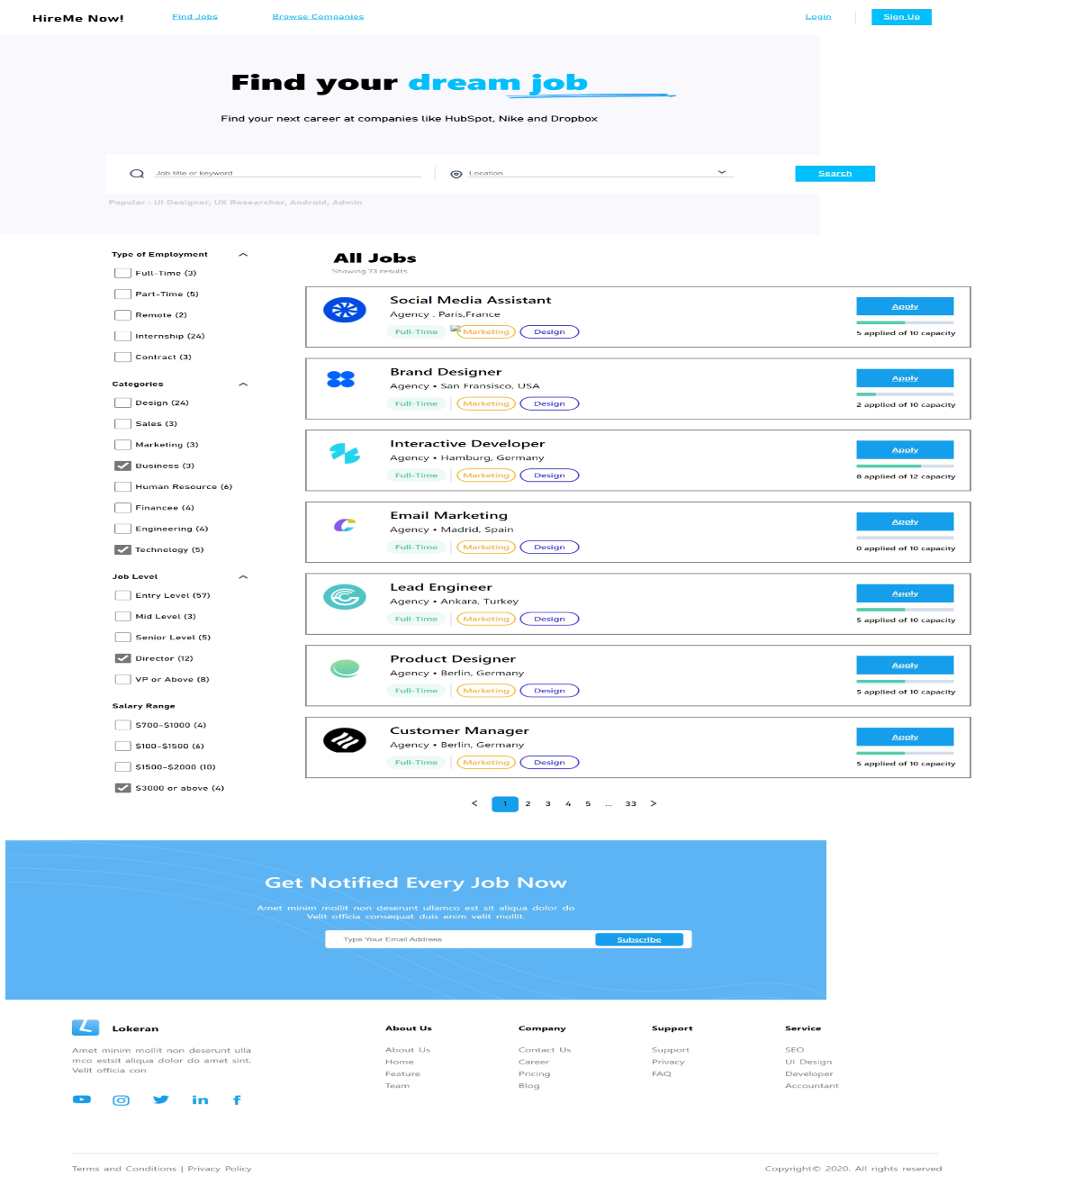

Expected Output:


During this workshop, we will be constructing a page for jobPortalSystem. On this page, we will load job details using the JavaScript loadData() function. In the script, we will use arrays and DOM manipulation. Additionally, let's incorporate the last three job listings to get the expected output.

WORKSHOP2:
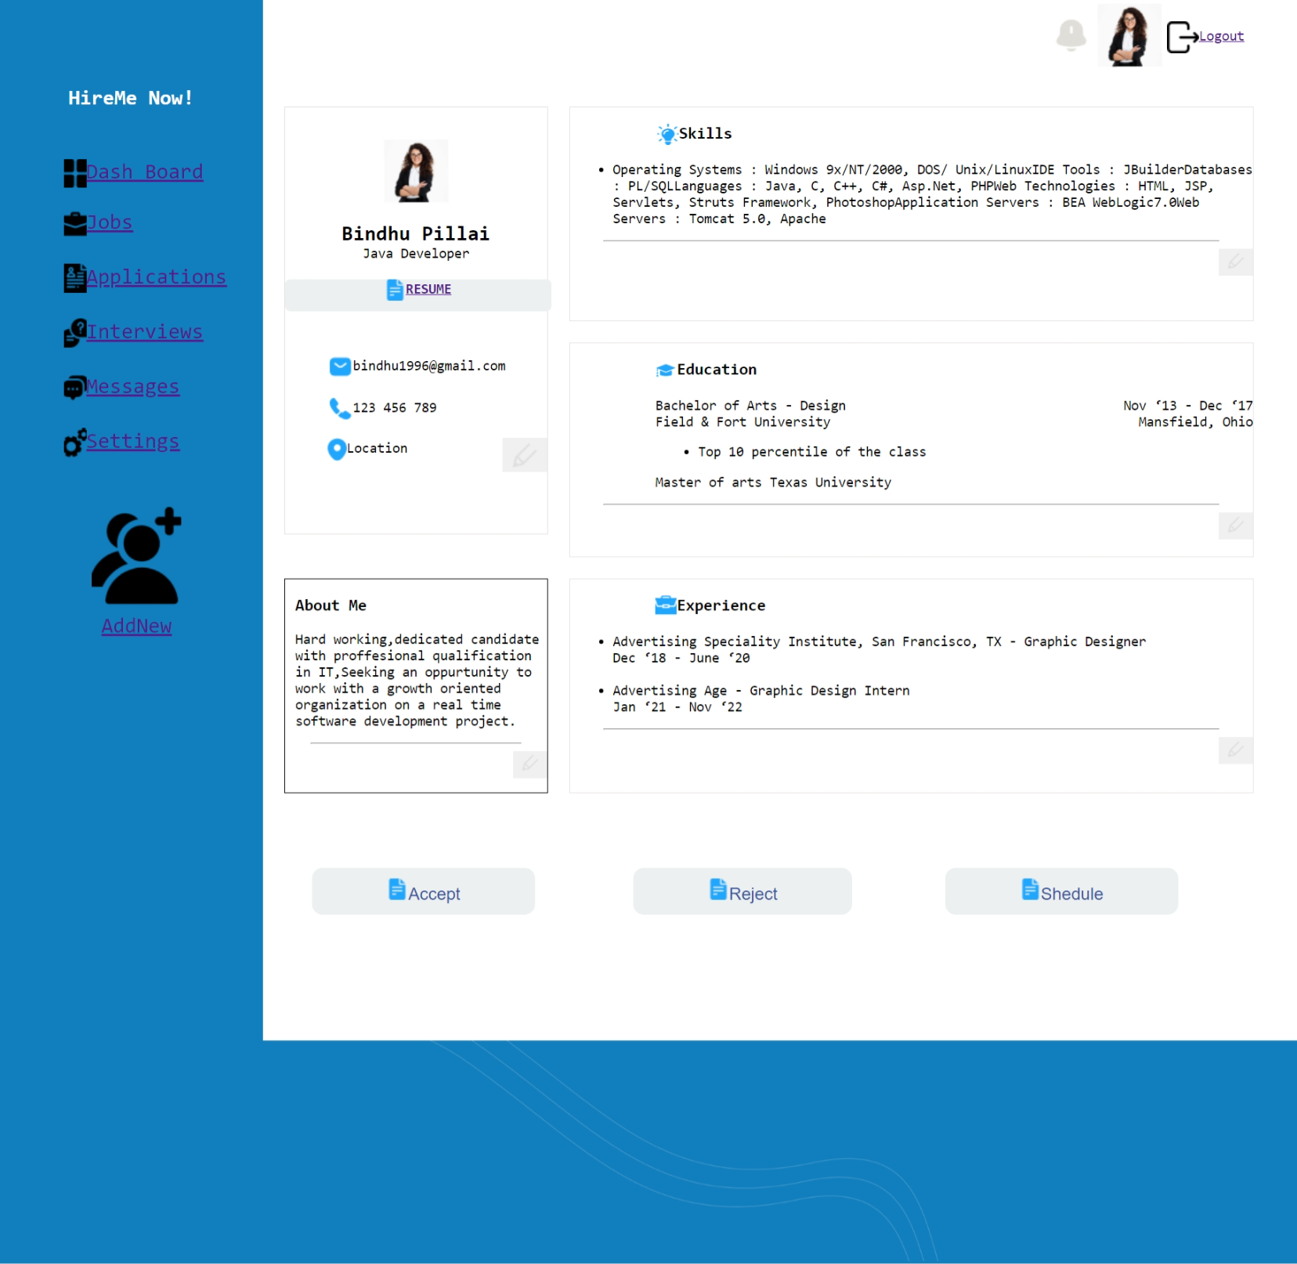

During this workshop, we will construct a page for a job portal system. On this page, we will implement the ability to edit skills and education information within a user's profile using JavaScript. When the edit icon is clicked, an input box and an "add" button will be displayed. If data is provided in the input box and the "add" button is clicked, the provided data will be added to the respective list for each section. Additionally, you should also include the ability to update the 'About Me' and 'Experience' sections of the profile.

WORKSHOP3:


Expected Output:


During this workshop, we will create a webpage for a job portal system. On this page, we will display applicant details, including their image, name, and experience, using arrays and the DOM. We will achieve this by implementing the listApplicant() function. In addition, you should include fields for the applicant's location and qualifications.

